

Artificial Intelligence
( Course Code: CSC262 )

Name : Syeda Aima Abbas
Roll No # FA24-BSE-010
Instructor Name : Sir Waqas

Lab # 1

Lab Task – 1

str = input("Enter a string you want to reverse: ")

reversed_str = ""
for i in range(len(str) - 1, -1, -1):
reversed_str += str[i]

print("Reversed string is:", reversed_str)

Output:
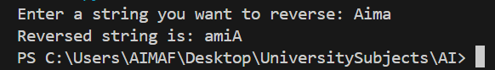
Lab Task – 2
even_sum = 0
odd_sum = 0

n = int(input("How many numbers do you want to enter? "))

for i in range(n):
num = int(input(f"Enter number {i+1}: "))
if num % 2 == 0:
even_sum += num
else:
odd_sum += num

print("Sum of even numbers =", even_sum)
print("Sum of odd numbers =", odd_sum)

Output:
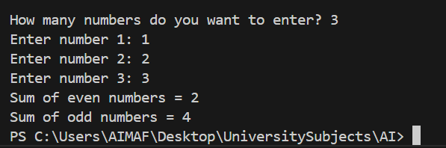
Lab Task – 3
terms = int(input("Enter the number of terms: "))

a, b = 0, 1
print("Fibonacci Series:")

for i in range(terms):
print(a, end=" ")
a, b = b, a + b

Output:
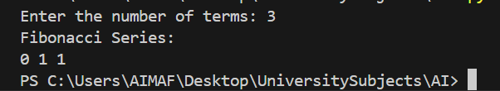

Lab Task – 4
marks = int(input("Enter marks (1-100): "))

if marks < 50:
grade = "F"
elif marks <= 60:
grade = "E"
elif marks <= 70:
grade = "D"
elif marks <= 80:
grade = "C"
elif marks <= 90:
grade = "B"
elif marks <= 100:
grade = "A"
else:
grade = "Invalid input"

print("Grade:", grade)

Output:
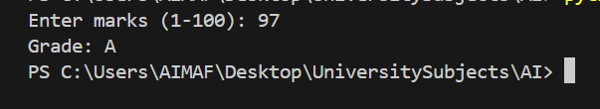
Lab Task – 5
n = int(input("Enter a number: "))
fact = 1

for i in range(1, n + 1):
fact *= i

print("Factorial of", n, "is", fact)

Output:
